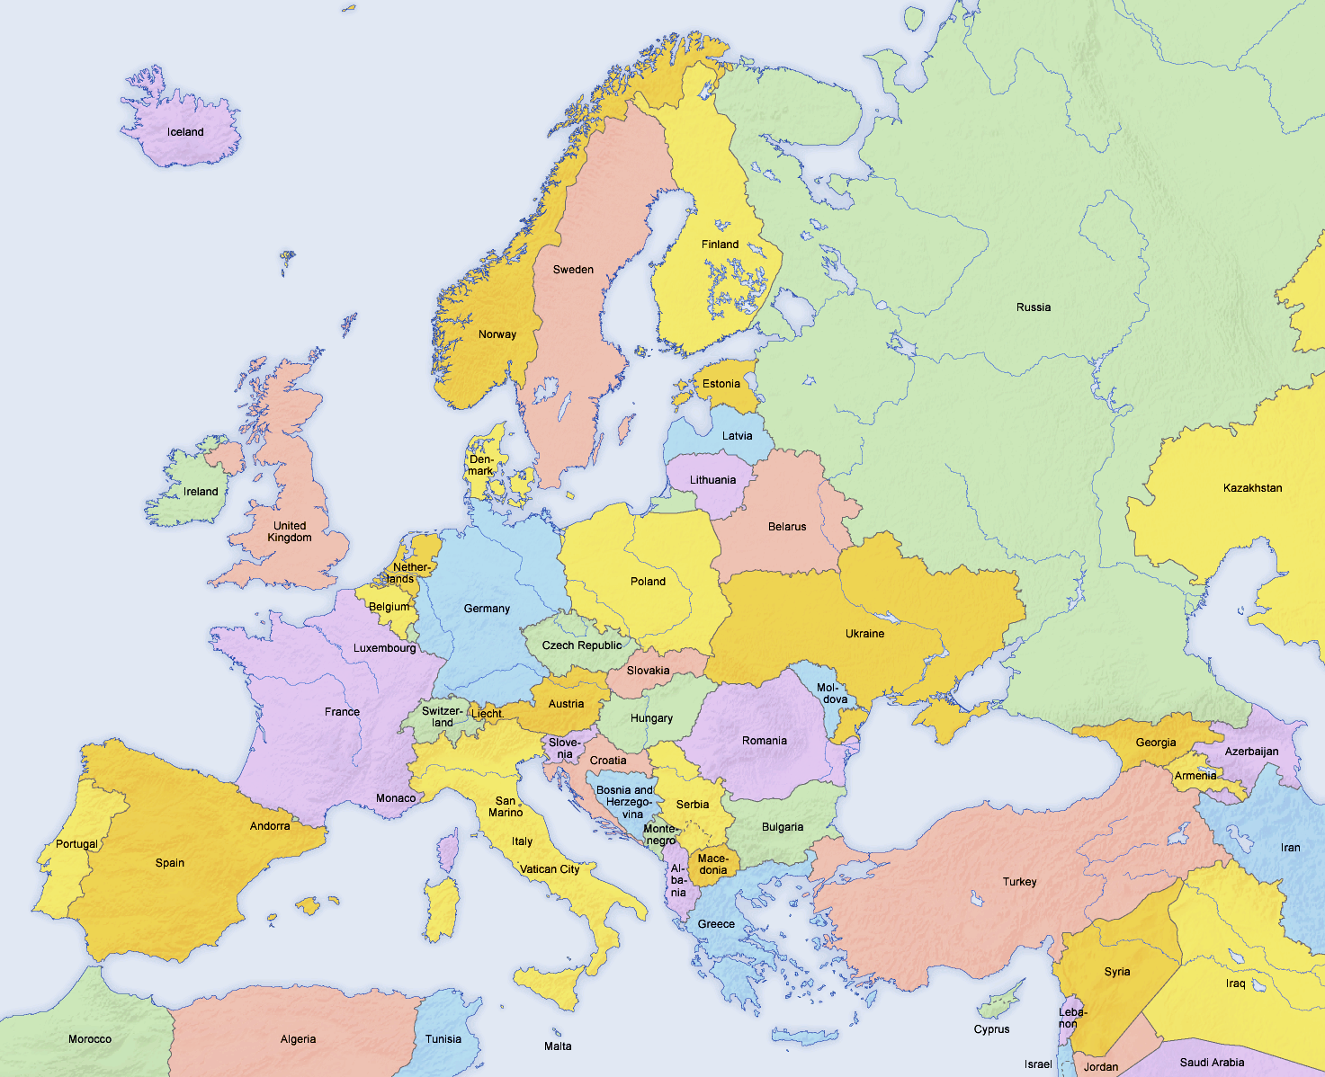
Europe 2016
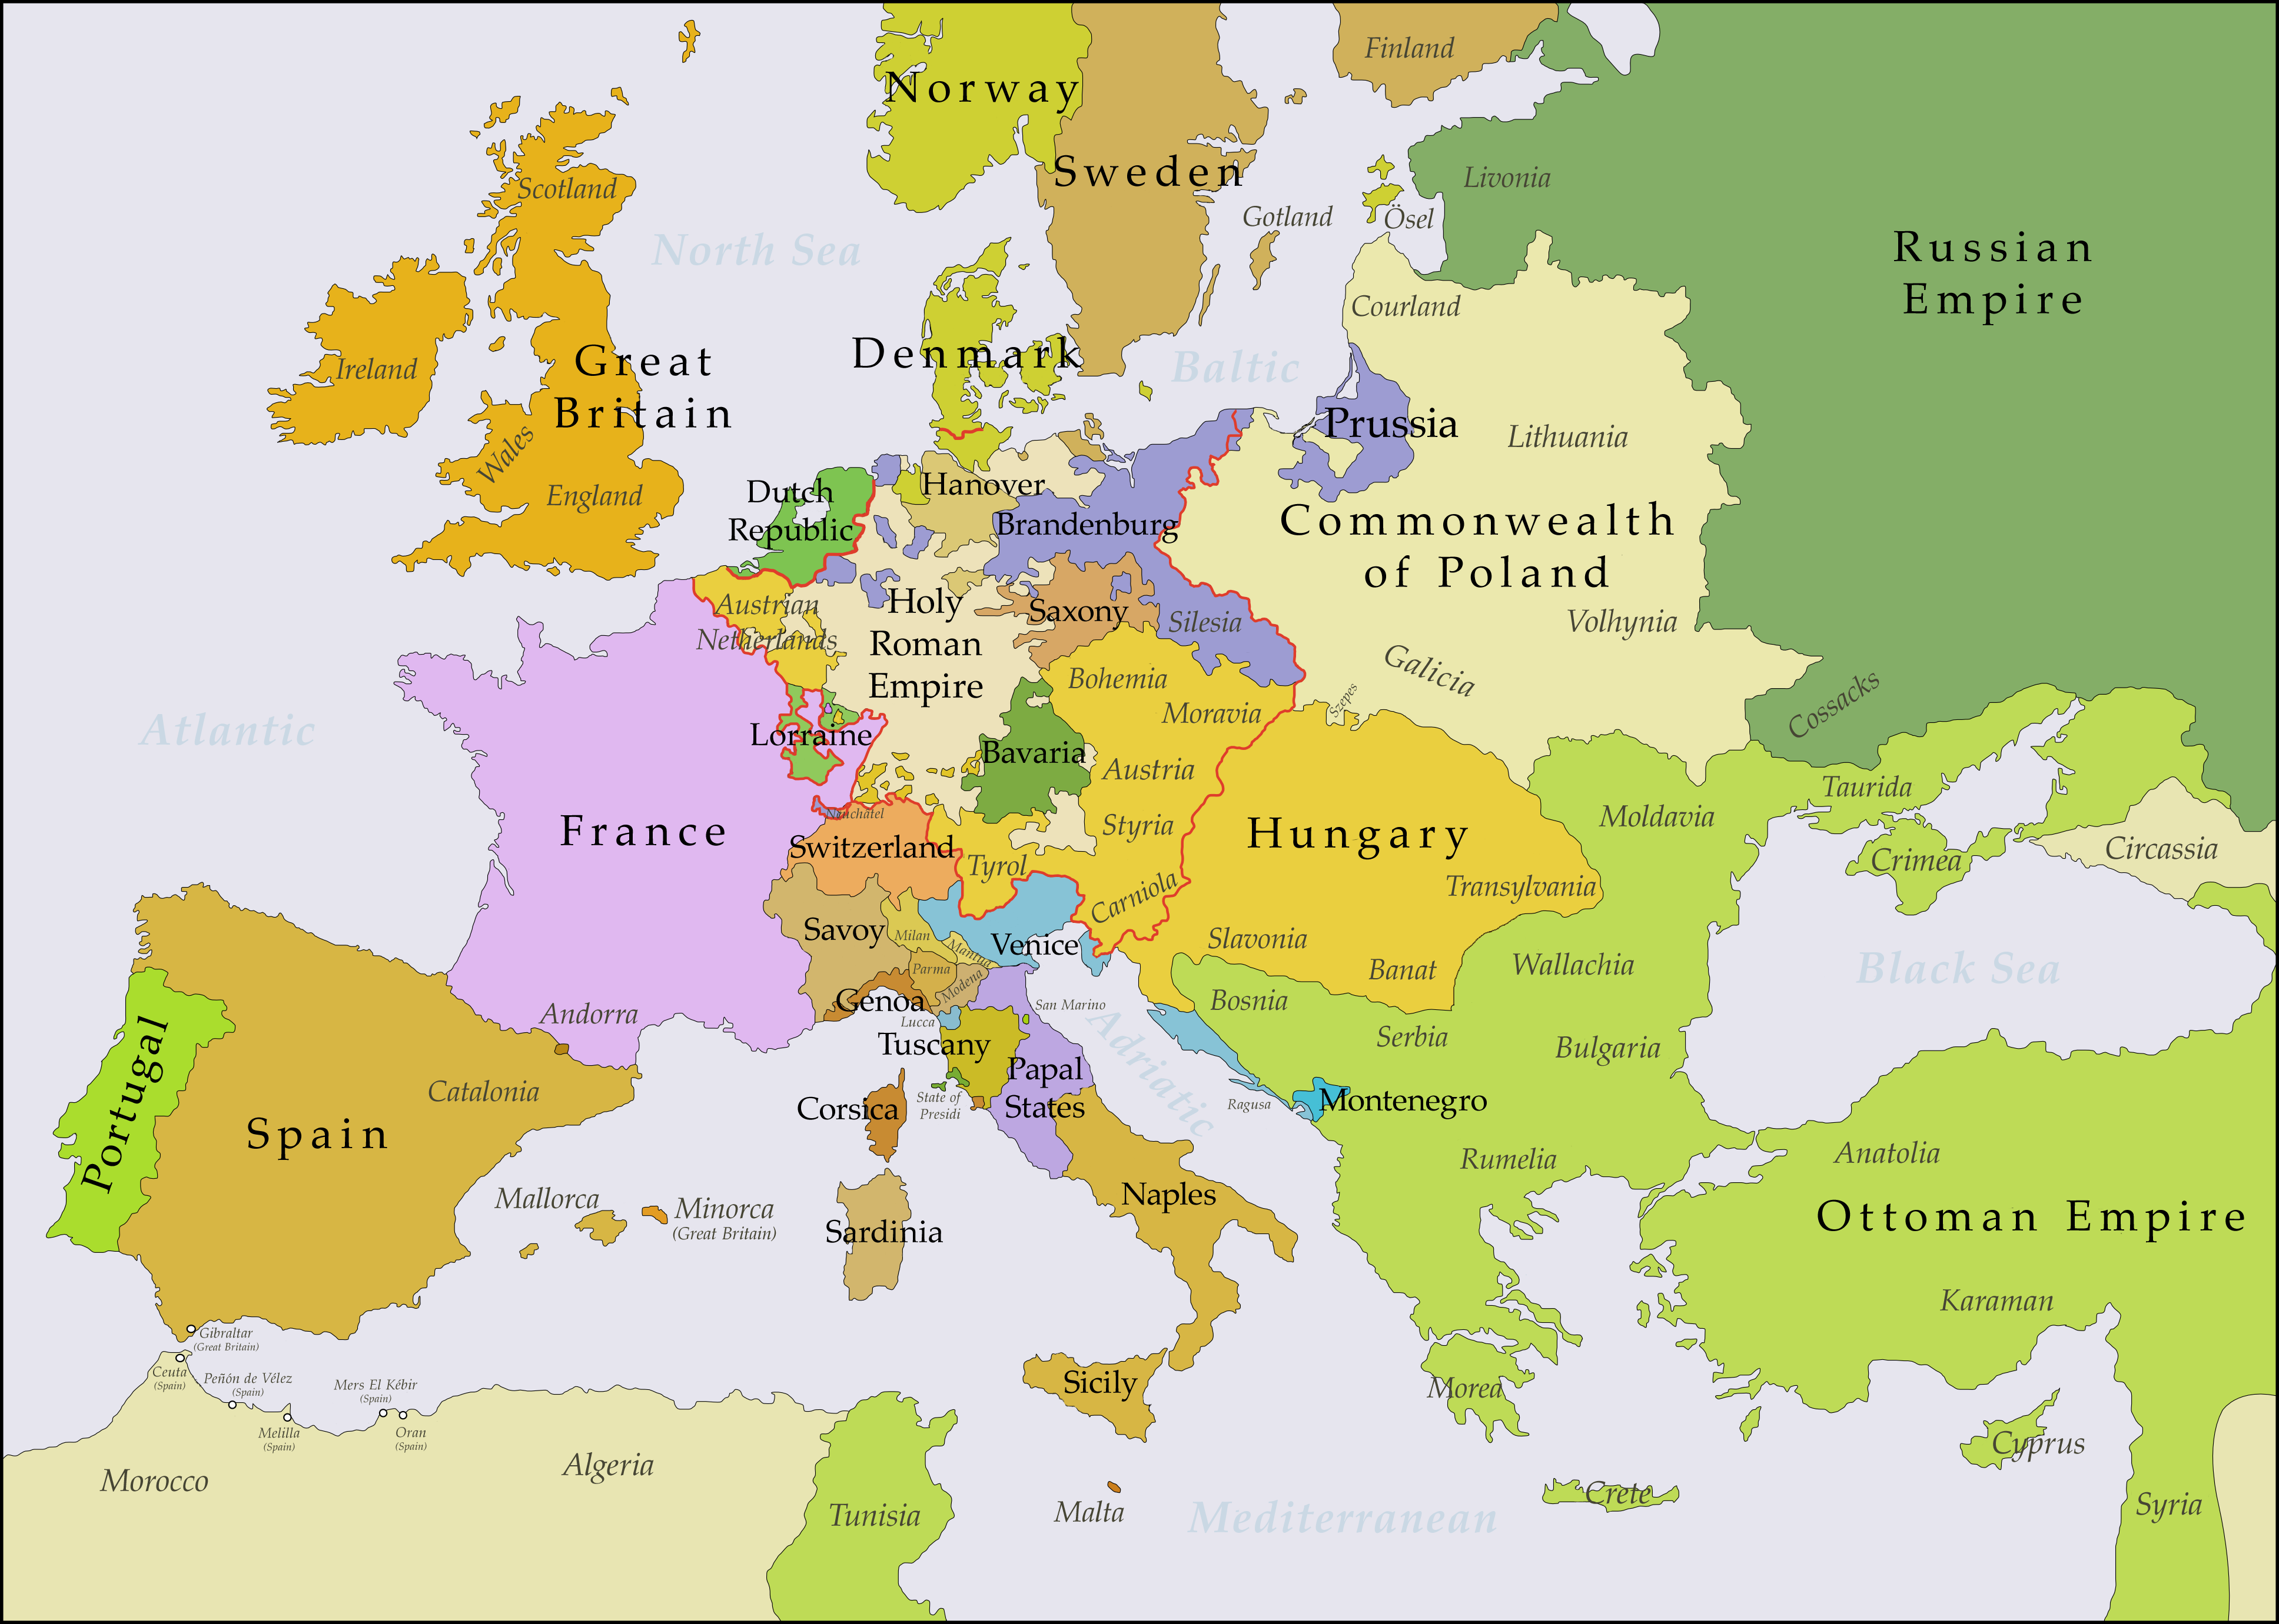
Europe 1750
Directions:

1. Read over both maps carefully:
- Look at the names of the countries. Think about ones you have heard before and ones you haven’t.

2. Compare and contrast the two maps with your group:
- Figure out how the maps are similar and different to one another.
Be sure to keep an eye out for:
a. Countries that are on one map and not the other
b. Sizes of countries
c. Amount of countries
d. Countries that appear on both maps

3. With your group, discuss why the similarities and differences exist between the maps and why these differences are important!

